THREE TIER APPLICATION ON AWS

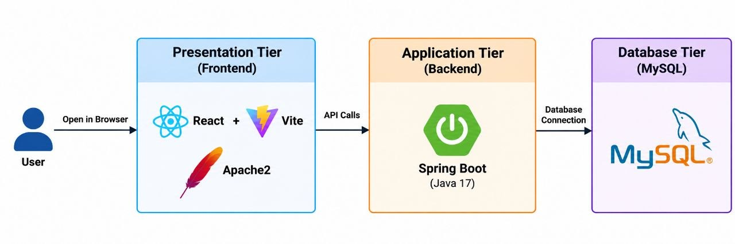
ON SERVER
1.create a instance
- Name ----------> webserver
- Ami -------------> ubuntu
- Instance type -> m7i.flex. large
- Sg ---------------> mysg (http/https/ssh/mysql)
- Create a instance
2.create a database
- Engine ------------> MySQL
- Choose full configuration
- Username -------> admin
- Password --------> admin123
- Create a database
3.access the instance
- apt update
- apt install mysql-client -y
4.create a user inside the MySQL
- mysql -u admin -h <database-endpoint> -padmin123
- create database student_db;
- show databases;
5.Access the instance
- git clone https://github.com/mayurpandit25/EasyCRUD-Updated-df.git
- apt install openjdk-17-jdk -y
- apt install maven -y
6.setup the backend
- cd /EasyCRUD-Updated-df/backend/src/main/resources
- vim application.properties
{ change username, password & database endpoint }
- cd /EasyCRUD-Updated-df/backend/
- mvn clean package
- cd target
- java -jar student-registration-backend-0.0.1-SNAPSHOT.jar

7.setup the frontend
- cd /EasyCRUD-Updated-df/frontend/
- vim .env
VITE_API_URL=http://<public_ip>:8080/api
- sudo apt install nodejs npm -y
- apt install apache2 -y
- systemctl start apache2
- npm install
- npm run build
- cp -rf dist/* /var/www/html/
- systemctl restart apache2
8.<public_ip> ----------> hit on web

ON LOCAL
1.On Local ubuntu terminal
- apt update
- apt install mysql-server -y
- systemctl start mysql
- mysql
- create database student_db;
- CREATE USER 'admin'@'localhost' IDENTIFIED BY 'admin123';
- GRANT ALL PRIVILEGES ON student_db.* TO 'admin'@'localhost';
- FLUSH PRIVILEGES;
- mysql -u admin -h localhost -padmin123
2.DEPLOY PROJECT
- git clone https://github.com/mayurpandit25/EasyCRUD-Updated-df.git
- apt install openjdk-17-jdk -y
- apt install maven -y
3.setup the backend
- cd /EasyCRUD-Updated-df/backend/src/main/resources
- vim application.properties
- username -> admin
- password -> admin123
- database endpoint -> localhost
- cd /EasyCRUD-Updated-df/backend/
- mvn clean package
- cd target
- java -jar student-registration-backend-0.0.1-SNAPSHOT.jar
4.setup the frontend
- cd /EasyCRUD-Updated-df/frontend/
- vim .env
- VITE_API_URL=http://localhost:8080/api
- sudo apt install nodejs npm -y
- apt install apache2 -y
- systemctl start apache2
- npm install
- npm run build
- cp -rf dist/* /var/www/html/
- systemctl restart apache2
5.To check application
{ localhost }
6.To check the backend servers
{ localhost:8080/api }

